PRESS RELEASE
COMMUNICATION AND MEDIA TEAM 43RD ASEAN SUMMIT 2023
No.85/SP/TKM-ASEAN2023/ENG/9/2023

Indonesia agrees on national LCT task force formation to boost economic resilience
JAKARTA, SEPTEMBER 5, 2023 - Indonesia government has agreed on the formation of the National Local Currency Transactions (LCT) Task Force as a means for coordinating and synergizing policies among ministries and government agencies in increasing local currency transactions.
The Memorandum of Understanding (MoU) on Cooperation and Coordination for Increasing the Use of Local Currency in Indonesia's Transactions with Partner Countries was signed on the ASEAN-Indo-Pacific Forum (AIPF) flagship event held at Mulia Hotel, Jakarta, on Tuesday (5 Sept 2023).
Ministries and government agencies that signed the MoU are Bank Indonesia (BI), the Coordinating Ministry for Economic Affairs, the Coordinating Ministry for Maritime Affairs and Investment, the Finance Ministry, the Ministry of Foreign Affairs, State-Owned Enterprises (SOEs) Ministry, Trade Ministry, Industry Ministry, the Financial Services Authority (OJK) and Deposit Insurance Corporation (LPS).
The signing of the MOU, which was witnessed by President Joko Widodo (Jokowi), was carried out by Coordinating Minister for Economic Affairs Airlangga Hartarto, Coordinating Minister for Maritime Affairs and Investment Luhut Binsar Pandjaitan, Foreign Minister Retno Marsudi, BI Governor Perry Warjiyo, SOEs Minister Erick Thohir, Finance Minister Sri Mulyani, Industry Minister Agus Gumiwang Kartasasmita, Trade Minister Zulkifli Hasan, OJK Board of Commissioners Head Mahendra Siregar and LPS Board of Commissioners Head Purbaya Yudhi Sadewa.
The task force was forged as a means to bolster policy synergies among ministries/government agencies in increasing the use of local currency in Indonesia's bilateral transactions with major partner countries.
It will formulate policy recommendations that would encourage business players in increasing the use of local currency in trade transactions and direct investment, including coordination on implementing policies or regulations in banking and financial sector.
The Task Force would support the expansion of the use of local currency in payment transactions between participating countries. Hence, it will strengthen the stability of Rupiah exchange rate, as also the resilience of domestic financial market.
LCT implementation is expected to contribute positively to export-import activities, investment, and cross-border payment transactions, among others, by using cross-border QR, including facilitating securities trade transactions.
Formation of this National LCT Task Force is the government effort to implement the ASEAN high-level principles on the LCT framework as one of the priority achievements of Indonesia's ASEAN chairmanship in 2023, especially to encourage the use of local currency to reduce vulnerability to external volatility and deepen financial markets.
The LCT cooperation has been implemented by Indonesia and several countries in the region, including Malaysia, Thailand, Japan and China. In addition, Indonesia has also reached a joint agreement with Singapore and South Korea to develop the LCT cooperation implementation framework.

***
For more information, please contact:
Director General of Information and Public Communication, Ministry of Communication and Information – Usman Kansong (0816785320).
More information, please visit http://asean2023.id, https://infopublik.id/kategori/asean-2023, dan https://indonesia.go.id/kategori/ragam-asean-2023

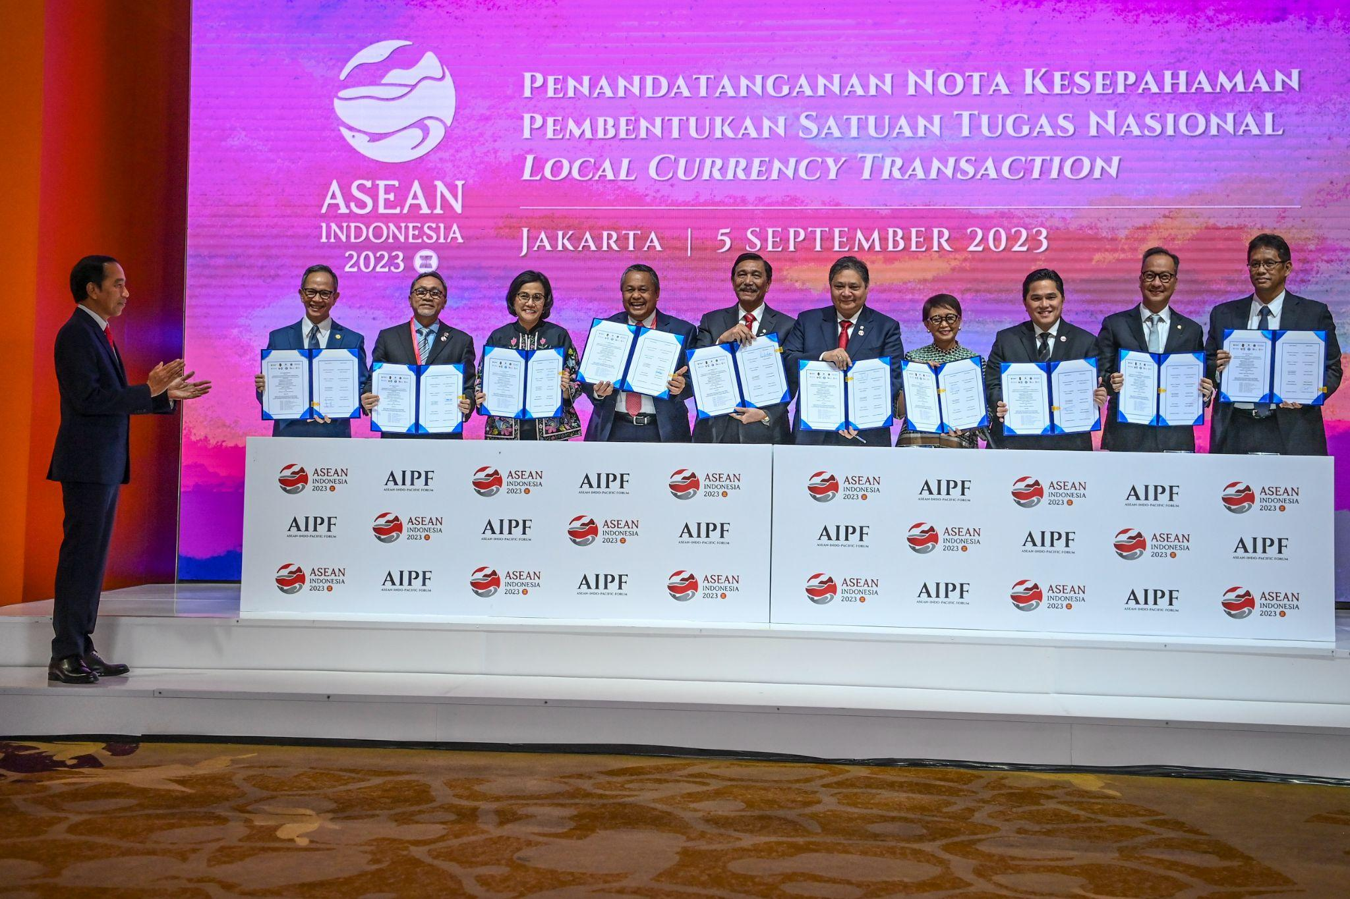
Presiden Joko Widodo witness the MOU signing of the formation of the National Local Currency Transactions (LCT) Task Force
Foto: Media Center KTT Asean 2023/Galih Pradipta/aww.

